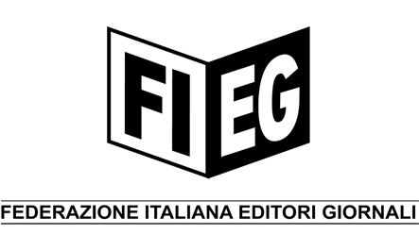

STATEMENT
ROME – 16 MARCH 2007

ENPA - EUROPEAN NEWSPAPER PUBLISHERS’ ASSOCIATION AND ITS ITALIAN MEMBER ASSOCIATION FIEG CALLS ON COMMISSION AND COUNCIL TO RESPECT PRESS FREEDOMS IN TV DIRECTIVE REVISION

At its meeting in Rome on 16 March 2007, the Executive Committee of the European Newspaper Publishers’ Association (ENPA) examined the different challenges and opportunities of the newspaper publishing industry in the context of EU legislation and policy under discussion. This focussed particularly on the problems raised by the revision of the “Television without Frontiers Directive”, set in motion by the European Commission with the proposal of the “Audiovisual Media Services Directive” on 13 December 2005.

The European newspaper publishers are deeply concerned about the evolution that is taking place in the revision process and calls again on the Commission and the Council of the European Union to carefully consider the following:

- Newspapers in all their forms of delivery should be kept out of the Directive because of their special role in society that gives them their unique personality upholding the freedom of the press. The original version of the Commission’s proposal excluded electronic newspapers and magazines only in recital 15, which would mean that there would remain a question of to what extent this would be legally binding. The exclusion for the electronic press was very appropriately inserted by the European Parliament into Article 1 of the Directive under the definition of “audiovisual media services”. ENPA considers that it will be of fundamental importance to confirm the exclusion in Article 1 in the final Common Position to be approved by the Council, mainly to avoid legal uncertainties and misinterpretations that could otherwise arise regarding electronic newspapers’ status.
- Product placement is one of the major worries of the European publishers. The weakening of the principle of separation between advertising and editorial content threatens the credibility of all media. The Directive must prohibit product placement wherever it threatens editorial independence and particularly when it reduces the distinction between the advertising and editorial parts. ENPA would therefore support a general prohibition on product placement, with limited derogations for certain genres and room for EU Member States to introduce a total ban on this form of advertising.
- As for hourly limits for advertising (12 minute rule), the wording of Article 18 of the draft Directive leads to the consequence that all forms of advertising different from “short” forms of advertising would fall outside any hourly limitation. It is indeed evident that the exclusion of advertisements other than spots, from the hourly limit, would result in an overall increase of these forms of advertising that are not calculated in the limit. The European publishers’ position is to eliminate the references to “short forms of advertising” and “advertising spots” in article 18, in line with the need of introducing only a general rule for all broadcast advertising and leaving it to the Member States to define which forms of broadcast advertising should be included in the hourly limit.

ENPA is a non-profit organisation of 5100 titles from 24 European countries representing the interests of newspaper publishers to the European Institutions. More than 120 million copies of newspapers are sold each day and read by over 235 million people in Europe.

For further information, please contact:

Mr. Valtteri Niiranen – Director
ENPA - European Newspaper Publishers' Association
Rue des Pierres 29, bte 8
B-1000 Brussels
BELGIUM
Tel. + 32.2.551.01.90
Fax. + 32.2.551.01.99

